Test in ICT
Section 1: Multiple Choice Questions (Each correct answer 1 point)

1. What is the purpose of a variable in Python?
a) To store and manipulate data
b) To perform mathematical calculations
c) To display output on the screen
d) To execute conditional statements

2. Which of the following is a valid Python variable name?
a) 123_variable
b) _variable123
c) variable 123
d) variable#123

3. What will be the output of the following code?(consider data type)
x = 5
y = 2
result = x // y
print (result)
a) 2.5
b) 2
c) 2.0
d) 2.2

4. How do you take user input in Python?
a) get()
b) read()
c) input()
d) user_input()
5. Which of the following is a valid way to comment a single line in Python?
a) /* This is a comment */
b) // This is a comment
c) # This is a comment
d) <!-- This is a comment -->
6. What will the following code print if the user inputs 0?
number = float(input("Enter a number: "))
if number > 0:
print("Positive")
elif number < 0:
print("Negative")
else:
print("Zero")
- A) Positive
- B) Negative
- C) Zero
- D) Error
7. Which of the following statements correctly generates a random number between 1 and 10 in Python?
- random.randint(1, 10)
- random.random(1, 10)
- random.range(1, 10)
- random.randrange(1, 10)
Rearrange code correctly:(write numbers in order on the side)

- Declare program name.
- Ask for the total bill and then how many people are sharing it.
- Calculate .
- Write what the total bill was and how much each person has to pay.

print("What is the total bill?")
print("---Split The Bill---")
people = int(input())
cost_per_person = bill_total / people
print(f"Total bill is ${bill_total}")
print("How many people are sharing?")
bill_total = float(input())
print(f"Total cost per person is ${cost_per_person}")

Complete the table to state what will be the output based on the input:(4p)

1  2  3  4  5  6  7 | print("Enter a number: ")  odd_even = int(input())  odd_even = odd_even % 2  if odd_even == 1:  print("Your number is odd")  elif odd_even == 0:  print("Your number is even")

Input | Output
Twenty two
27
92
33

Match Data types with correct explanations:(5p)
Boolean Integer Float(Real) String Char List
Only two values TRUE - FALSE
A single character
A whole number
Number with fractional character
Several characters

Section 2: Code Writing (Write Python code to solve the problem)**

8. Write a Python program that generates a random integer between 1 and 100 and prints it.

9. Write a Python program that prompts the user for their age and then prints a message stating their age.

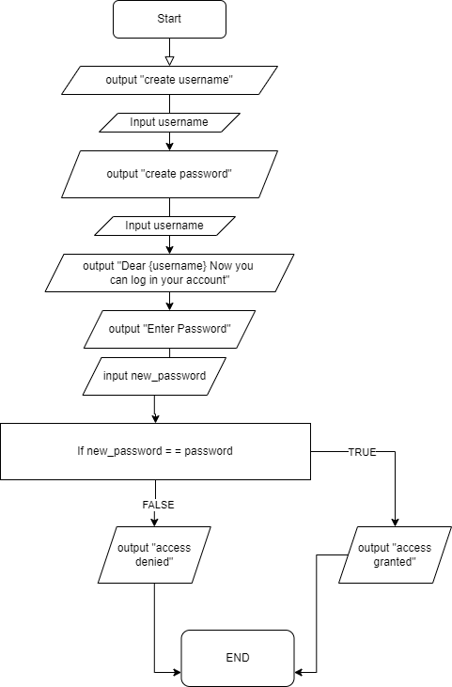
10. Write python code for the following flowchart.

11. Put in the correct missing pieces of the code.(6p)

print("What is your name?")
name = ()
if name == "anakin":
("How do you do Anakin!")
else:
print(f"Nice name ")
print(f"So {name}, is it hot or cold where you are today?")
weather = input()
if == "COLD":
print("You must be freezing!")
elif weather == "HOT":
print("Drink plenty of water")
:
print("I can't advise you on that type of weather.")
print("Do you like the colour blue?")
likes_blue = input()
if == "Yes":
print("I like blue too")
print("Have a good day! Bye!")

12. Find 5 (five) mistakes and correct them:(5p)

Print("Enter birth month (e.g. September):")
month = int(input())
if month = "June"
print("June is my favourite month")
else:
print(My birth month is June")

- Design a flowchart according to the code below:

1  2  3  4  5  6  7  8  9 | print("What is your first initial?")  initial = input()  print("What is your surname")  surname = input()  print("What is your age?")  age = int(input())  decades = float((age / 10))  print(f"Well hello {initial} {surname}.")  print(f"This is probably because you are {decades} decades old")

